No. | INSTRUCTIONS |  | KEY POINTS / CONTACTS
1. | Grease slides | 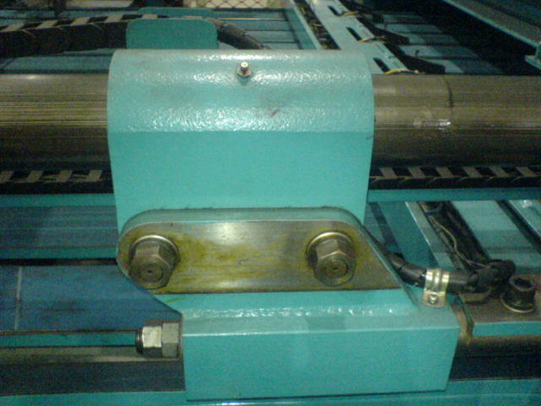 | ENSURE PERSONNAL PROTECTIVE EQUIPMENT (PPE) IS WORN: -  1. HARD HAT  2. STEEL CAP BOOTS  3. GLOVES  ENSURE LOCK- OUTS AND SAFETY BLOCKS ARE USED AT ALL TIMES.
2. | Grease cam bearings. | 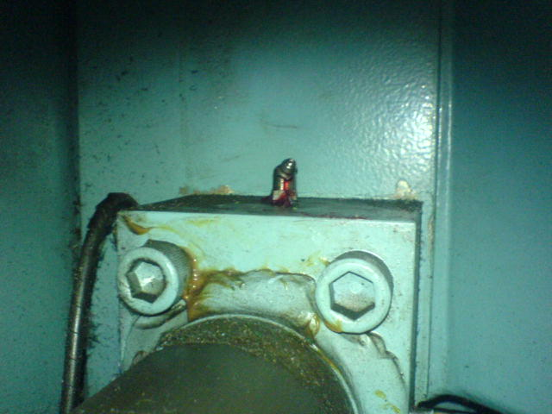
3. | Grease roller bearings. | 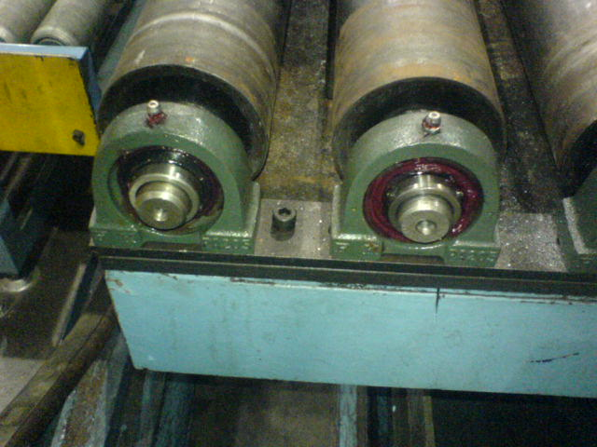
4. | Grease stacker bearing and chain. | 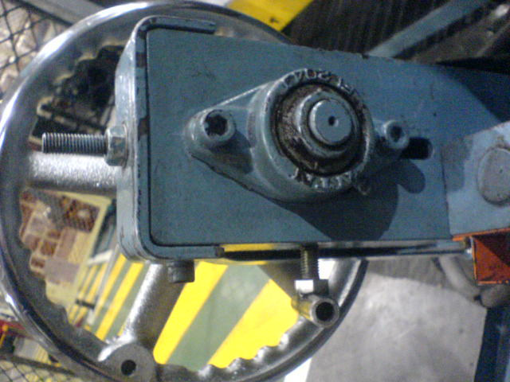
5. | Lubricate roller chains. | 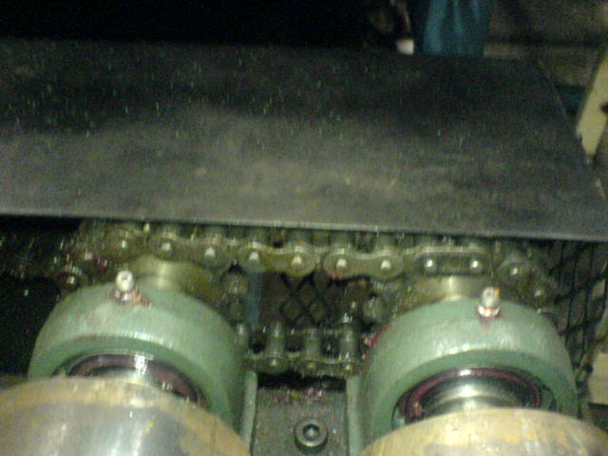
7. | Lubricate drive chain. | 